AIM
To design and develop a user-friendly e-commerce mobile application wireframe using Figma, enabling users to browse products, log in, and complete a purchase process efficiently.

PROCEDURE
- Open the Figma application and create a new design file.
- Select an appropriate mobile frame size (e.g., Android Compact).
- Design the Login Screen by adding input fields for username and password along with a login button.
- Create the Home Screen with a search bar and product categories such as Women’s Wear, Men’s Wear, and Kids’ Wear.
- Design the Product Listing Screen displaying product images, names, and prices.
- Add a Payment/Checkout Screen with a payment button to simulate the purchase process.
- Create a Payment Success Screen showing confirmation of successful transaction.
- Use alignment, spacing, and consistent color schemes to enhance UI design.
- Connect all screens using prototype links to simulate navigation flow.
- Preview the prototype to ensure smooth transitions between screens.

OUTPUT
- A complete e-commerce mobile app wireframe was created.
- The design includes the following screens:
  - Login Screen
  - Home/Categories Screen
  - Product Listing Screen
  - Payment Screen
  - Payment Success Screen
- The prototype demonstrates the user journey from login to successful purchase.
- Basic UI/UX principles such as consistency, clarity, and usability were applied.

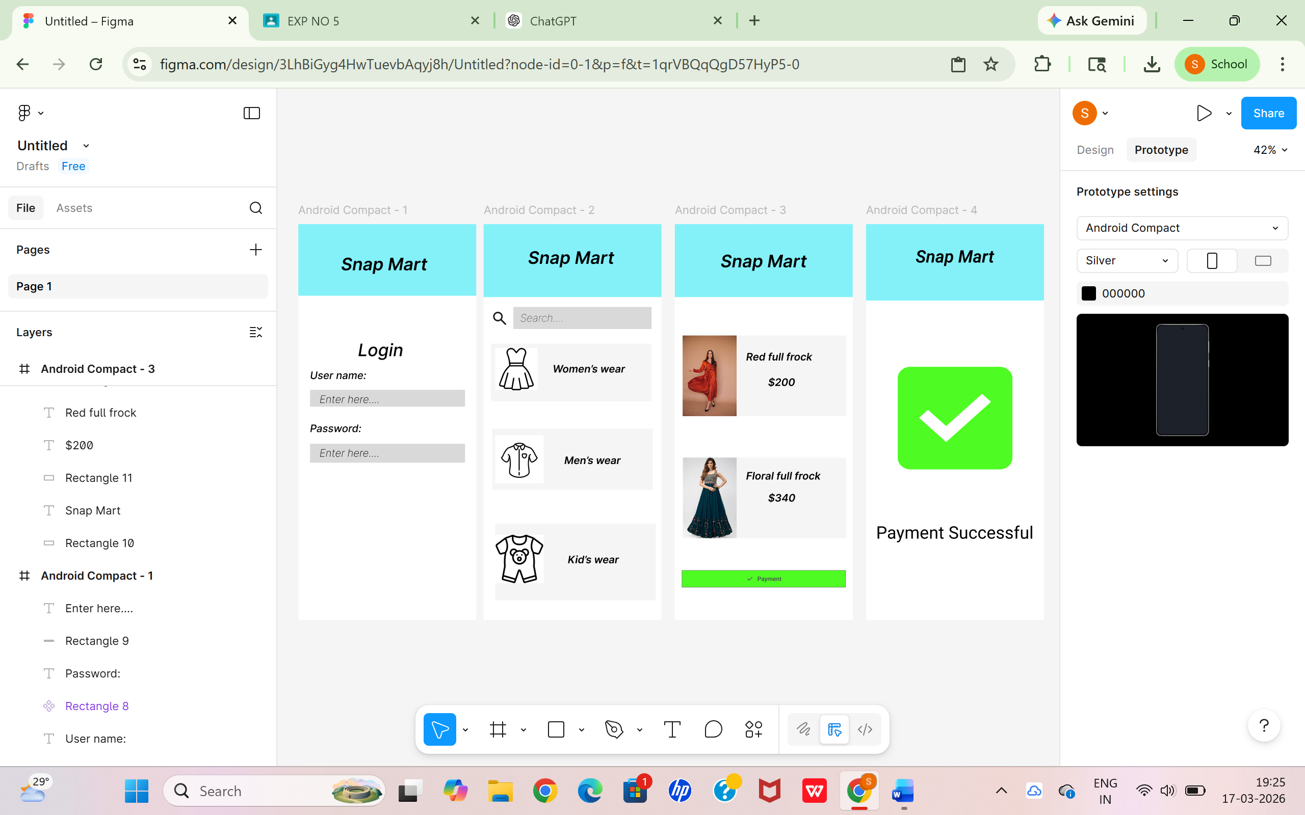

RESULT
The e-commerce application wireframe was successfully designed using Figma.
The prototype effectively represents the workflow of an online shopping app, allowing users to log in, browse products, and complete transactions.
This design can be further developed into a fully functional application.

